SET 23: EMPLOYEE PERFORMANCE ANALYSIS

Dataset | Employee Performance
Department | AIML
Course Code / Course Name | DSA0602 / Data Handling and Visualization
Experiment | Data Visualization using R
Name | A Shiva Shankar Reddy
Register Number | 192425174
Date | 15 October 2026
Day | Thurssday

Dataset: Employee Performance

Employee ID | Department | Years of Service | Performance Score
1 | Sales | 5 | 85
2 | HR | 3 | 92
3 | Marketing | 7 | 78
4 | Sales | 4 | 90
5 | HR | 2 | 76

PROGRAM 1: Bar Chart of Employees by Department
Question: In R, create a bar chart to visualize the distribution of employees across different departments. Label the chart elements.
# Dataset
department <- c("Sales", "HR", "Marketing", "Sales", "HR")

# Count employees in each department counts <- table(department)

# Bar Chart bp <- barplot(counts, main = "Distribution of Employees by Department", xlab = "Department", ylab = "Number of Employees", col = c("#4E79A7", "#F28E2B", "#59A14F"), ylim = c(0, 3))
text(bp, counts, labels = counts, pos = 3)

Output 1: Employees by Department Bar Chart

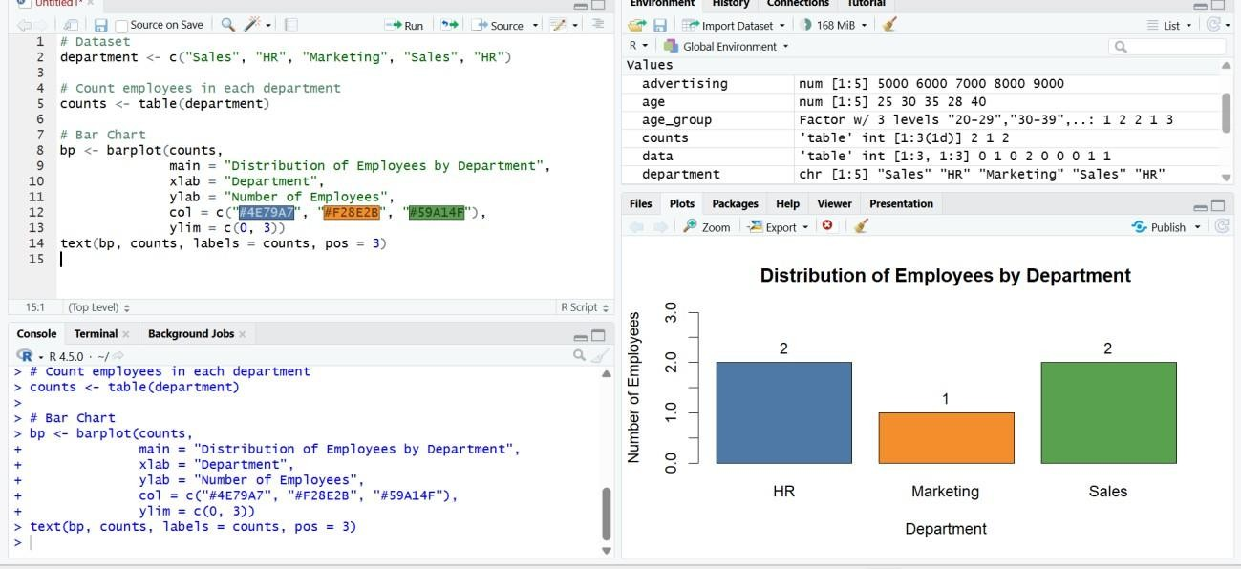
Observation: Sales and HR each have 2 employees and Marketing has 1 employee. Sales and HR together account for 80% of the five employees.

PROGRAM 2: Line Chart of Performance Trend
Question: In R, generate a line chart to visualize the performance trend of employees over time. Label the axes and title the chart.
# Dataset years <- c(5, 3, 7, 4, 2) score <- c(85, 92, 78, 90, 76)

# Order employees by years of service to see the trend ord <- order(years)

# Line Chart
plot(years[ord], score[ord], type = "o", main = "Employee Performance Trend by Years of Service", xlab = "Years of Service", ylab = "Performance Score", col = "#4E79A7", lwd = 2, pch = 16, ylim = c(70, 100))
text(years[ord], score[ord], labels = score[ord], pos = 3)

Output 2: Performance Trend Line Chart

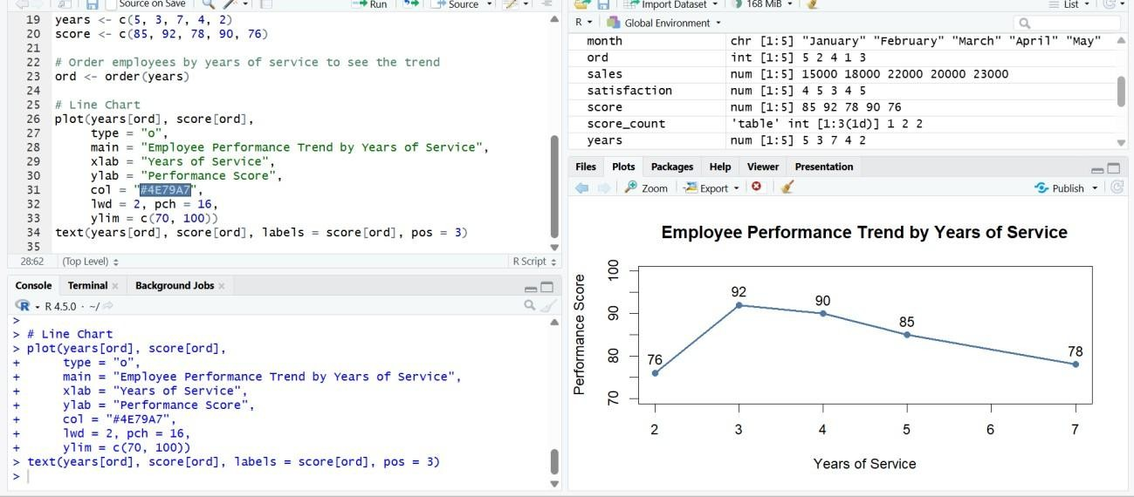
Observation: The dataset has no date column, so years of service is used as the time measure. The score rises from 76 (2 years) to a peak of 92 (3 years) and then falls steadily to 90, 85 and 78 as years of service increase to 7. Performance therefore does not keep improving with longer service in this data.

PROGRAM 3: Tableau Dashboard: Department Distribution and Performance Scatter
Question: In Tableau, build a dashboard combining a bar chart showing department distribution and a scatter plot displaying the relationship between years of service and performance scores.

Tableau Steps
- Open Tableau and connect to the Employee Performance dataset (Excel/CSV).
- Verify the fields: Employee ID and Department are dimensions; Years of Service and Performance Score are numeric measures.
- Create a worksheet named “Department Distribution”. Drag Department to Columns and Count of Employee ID (CNTD) to Rows; select Bar in the Marks card.
- Add the title “Employees by Department”, label the axes and show mark labels.
- Create a worksheet named “Service vs Performance”. Drag Years of Service to Columns and Performance Score to Rows; drag Employee ID to Detail so each employee is one point, and select Circle in the Marks card.
- Drag Department to Color, add the Employee ID to Label, and add a trend line (Analytics pane > Trend Line).
- Add the title “Years of Service vs Performance Score” and label both axes.
- Create a new Dashboard, set the size to Automatic, and drag in the bar chart and the scatter plot.
- Add the title “Employee Performance Dashboard”, click the “Use as Filter” icon on the bar chart and enable the Department quick filter.
- Test the dashboard by clicking a department bar and checking that the scatter plot updates.

Output 3: Employee Performance Dashboard (Tableau)

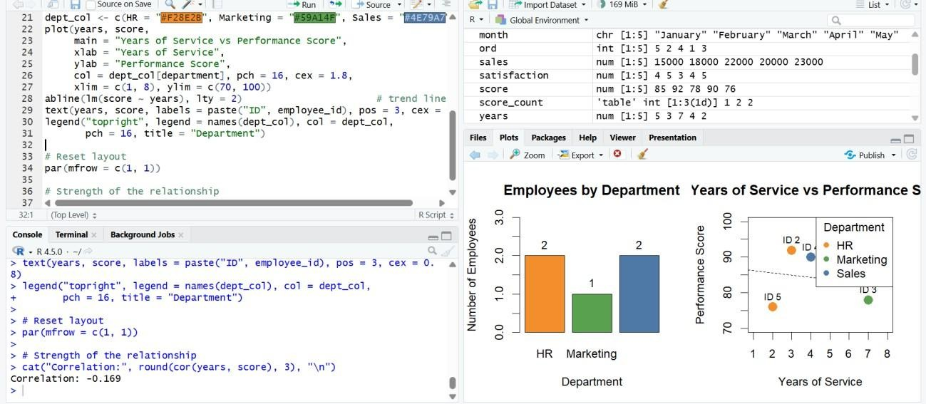
Observation: Clicking a department bar highlights that department's employees in the scatter plot. The scatter plot shows a weak negative relationship between years of service and performance (correlation about -0.17), so tenure alone does not explain performance. The HR employees have both the highest (92) and the lowest (76) scores.

PROGRAM 4: Employee Performance Table
Question: In R, develop a table showing the performance data for each employee. Label the table elements.
# Employee Performance Dataset emp_data <- data.frame(
Employee_ID = c(1, 2, 3, 4, 5),
Department = c("Sales", "HR", "Marketing", "Sales", "HR"),
Years_of_Service = c(5, 3, 7, 4, 2),
Performance_Score = c(85, 92, 78, 90, 76) )

# Display the table with labelled columns colnames(emp_data) <- c("Employee ID", "Department", "Years of Service",
"Performance Score")
print(emp_data, row.names = FALSE)

Output 4: Employee Performance Table

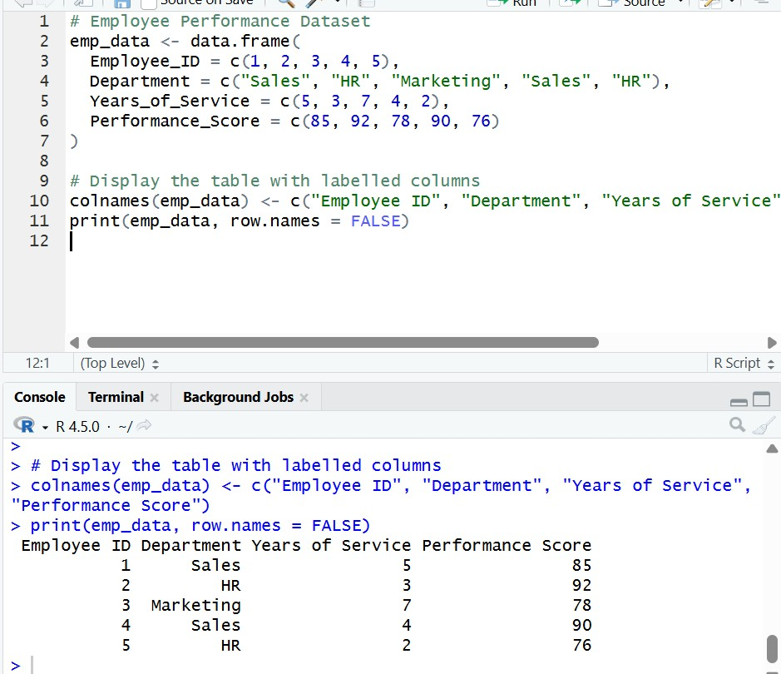
Observation: The table displays the Employee ID, Department, Years of Service and
Performance Score for each of the five employees. Employee 2 (HR) has the highest score (92), Employee 5 (HR) has the lowest (76), and the average score is 84.2.

Procedure
- Create the employee performance data in R.
- Count employees per department with table() and draw the bar chart using barplot().
- Order the employees by years of service with order() and draw the line chart using plot() with type = "o".
- Create a data frame with labelled columns and display it as a table using print().
- Open Tableau and import the Employee Performance dataset.
- Create the department bar chart and the years-of-service scatter plot as separate worksheets.
- Combine the worksheets into a dashboard, add a title, and enable filters.
- Test the dashboard interactivity.

Result
The Employee Performance data was successfully visualized using a bar chart of employees by department, a line chart of the performance trend, a labelled performance table, and an interactive Tableau dashboard.

